

**KRISHNA ENGINEERING COLLEGE**

**Data Structure Lab**

**KCS – 301**

SUBMITTED BY:-

**Sourabh Bhardwaj**

**1901610100207**

SUBMITTED TO:-

**Ms. RASHMI SHARMA**

|  |  |  |  |  |
| --- | --- | --- | --- | --- |
| |  | | --- | | **Krishna Engineering College**  **Department of Computer Science and Engineering** | | | |  |
| **Name: Sourabh Bhardwaj**  **Roll No.:1901610100207** | | |  |
|  |
| **Year/Semester:- 2nd/III** | | **Session:- 2020-21** |  |
| **Subject Name:- Data Structures** | | **Subject Code:- KCS-351** |  |
| **Faculty :-** | **Ms. Rashmi** | **Section/ Group: 2/B** |  |
|  |  |  |  |
| **S.No** | **Experiment /Program Name** | **Scheduled Date** | **Sign** |
|
| 1 | Traverse of array |  |  |
| 2 | Implementation of Linear search |  |  |
| 3 | Implementation of Binary search |  |  |

**Q11. WAP to implement Linear Search in C.**

#include <stdio.h>

#include <conio.h>

int main()

{

int a[6],i,key,found=1;

printf("enter only six elements in array\n");

for(i=0;i<6;i++)

{

scanf("%d",&a[i]);

}

printf("enter the element to be search\n");

scanf("%d",&key);

for(i=0;i<6;i++)

{

if(a[i]==key)

{

printf("the element is in %d position\n",i);

break;

}

}

return 0;

}

Output

enter only six elements in array

1

2

3

4

5

6

enter the element to be search

3

the element is in 2 position

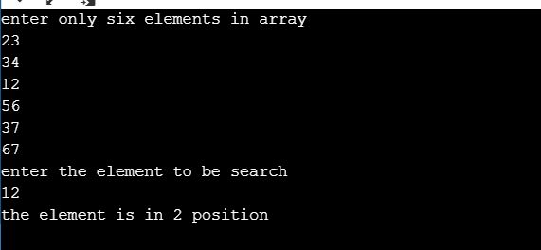

**Q12(A). WAP to implement BINARY Search in C.**

#include <stdio.h>

int main()

{

int i, low, high, mid, n, key, array[100];

printf("Enter number of elements");

scanf("%d",&n);

printf("Enter %d integers", n);

for(i = 0; i < n; i++)

scanf("%d",&array[i]);

printf("Enter value to find");

scanf("%d", &key);

low = 0;

high = n - 1;

mid = (low+high)/2;

while (low <= high) {

if(array[mid] < key)

low = mid + 1;

else if (array[mid] == key) {

printf("%d found at location %d.n", key, mid+1);

break;

}

else

high = mid - 1;

mid = (low + high)/2;

}

if(low > high)

printf("Not found! %d isn't present in the list.n", key);

return 0;

}

Output

Enter number of elements6

Enter 6 integers1

2

3

4

5

6

Enter value to find4

4 found at location 4.

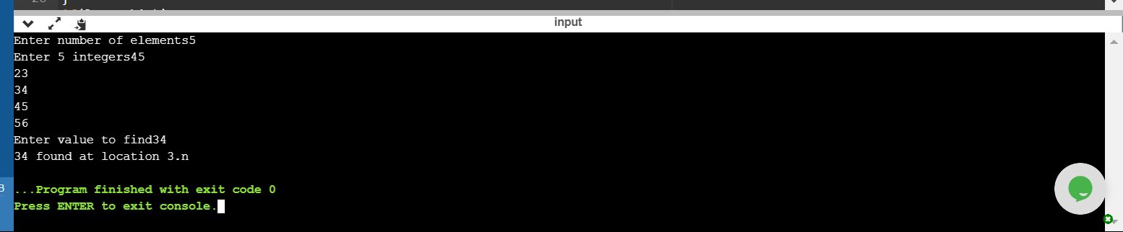

#include <stdio.h>

int main()

{

int n =5;

int a[] = {3, 6, 9, 12, 15};

for (int i = 0; i < n; i++)

{

printf("%d ", a[i], i);

}

return 0;

}

Output

3 6 9 12 15

